# How to use GitHub

1. **Register on GitHub**

If not registered, register here: <https://github.com/>. Then tell me your username, and I will add you to our repository, so that you can contribute to it.

1. **Install client**

I strongly commend you to use SourceTree: <http://www.sourcetreeapp.com/>. It’s a Git management software with very friendly GUI, which can free our work from command-lines.

1. **Local setup**
   1. Install embedded Git

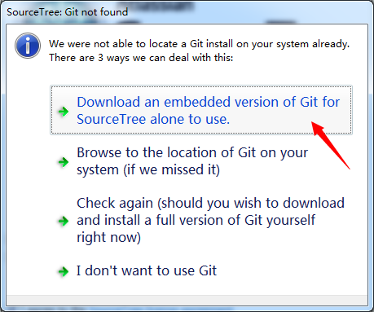

* 1. Skip install embedded Mercurial

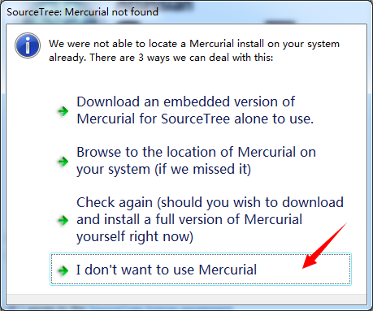

* 1. Input your user personal information

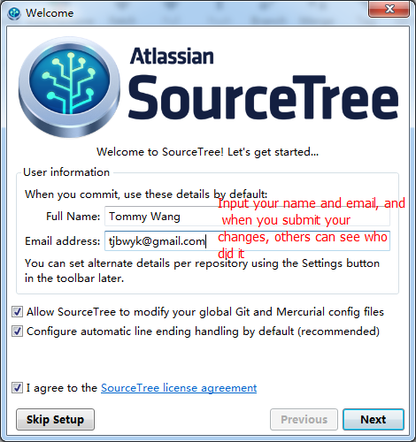

* 1. choose SSH configuration

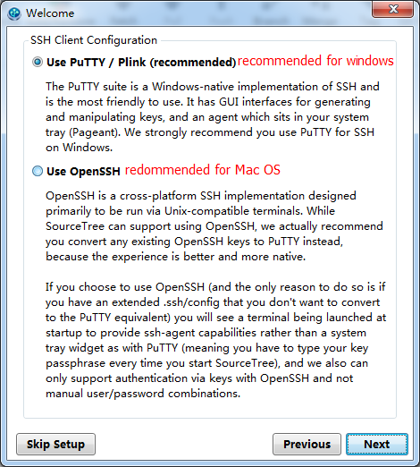

* 1. Connect to GitHub

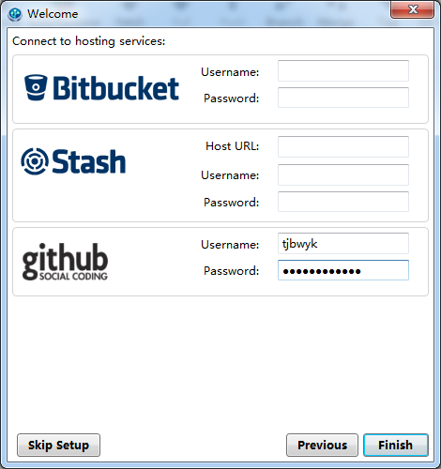

* 1. Setup SSH key (if you already have one, just import it, skip to ii)
     1. Generation

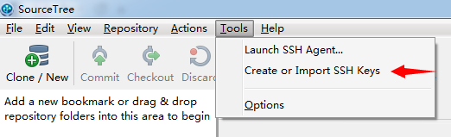

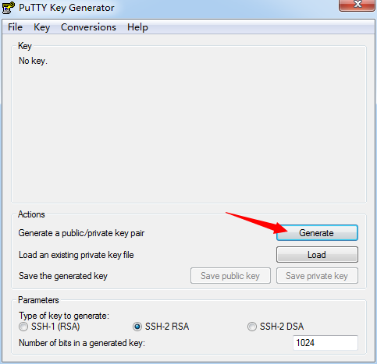

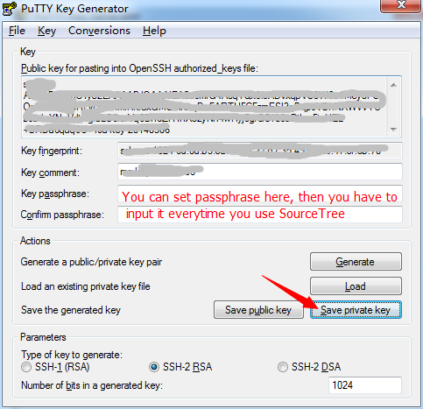

* + 1. Put the SSH Key into SourceTree

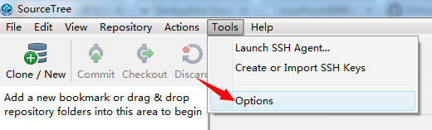

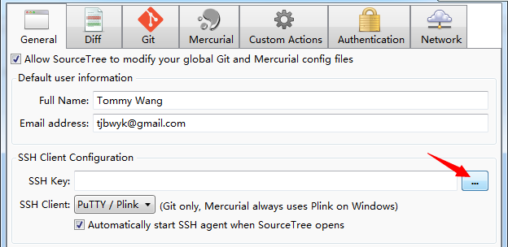

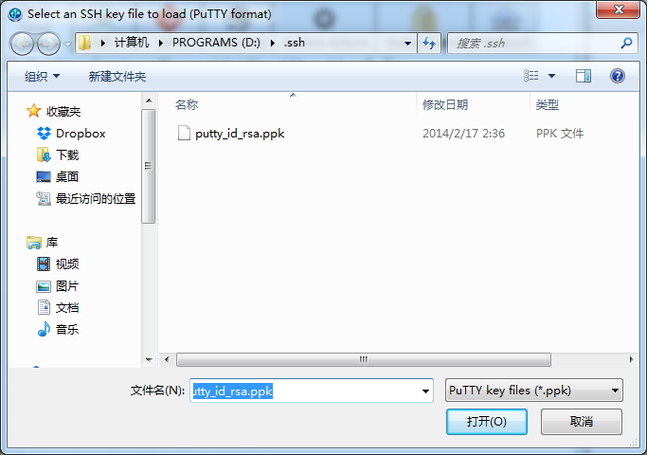

* 1. Download our project

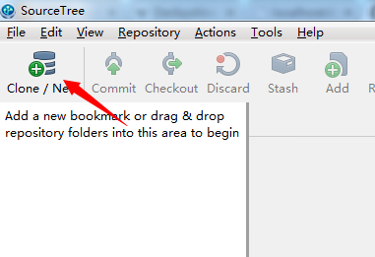

Repository URL: <https://github.com/tjbwyk/infovis.git>

